
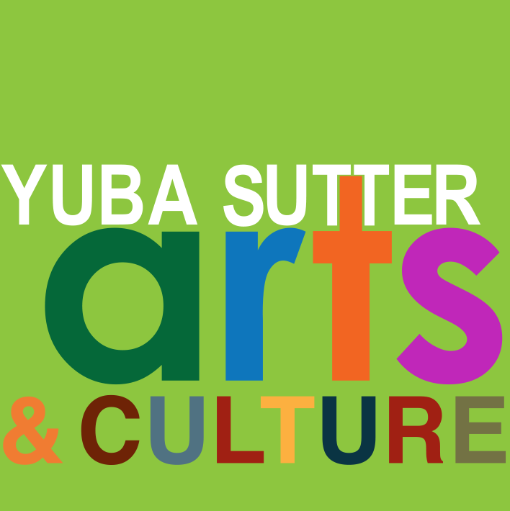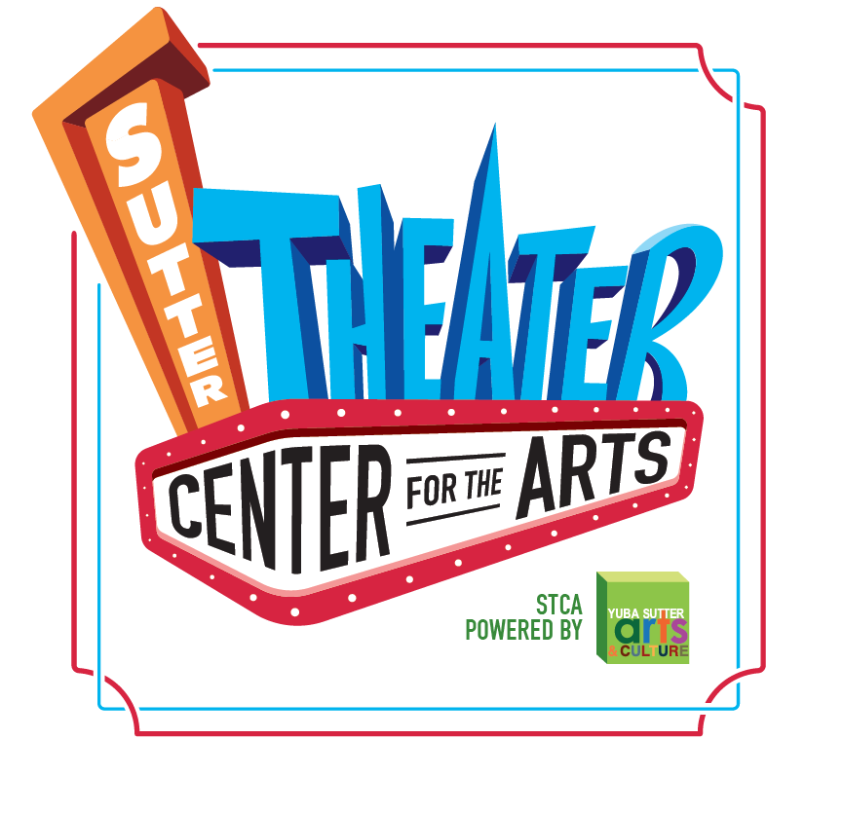
Media Contact:
Yuba Sutter Arts
David Read
530-742-2787
david@yubasutterarts.org

For Immediate Release

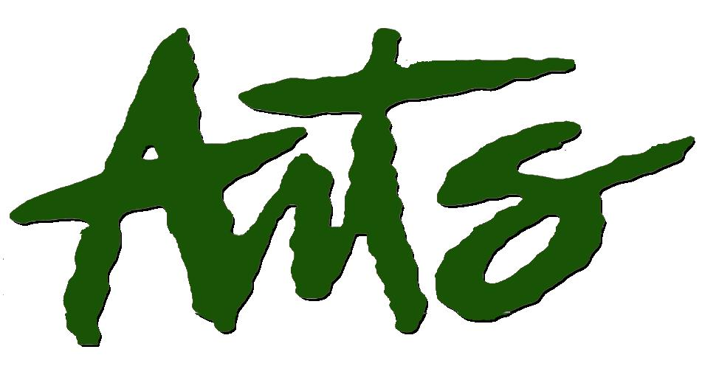
Keys & Cocktails Piano Bar
A Concert Featuring Gay Galvin and John Paris

Marysville, CA. August 15, 2025 – Following past years’ popular “176 Keys” and “Tickle the Ivories” concerts, our dueling pianists, Gay and John, are back for another great evening playing lots of your favorite tunes. It’s all happening on Saturday, September 13 when local piano greats Gay Galvin and John Paris again team up for an evening of piano jazz and standards from the American Songbook at the Sutter Theater Center for the Arts. The doors open at 6 pm and the concert starts at 7 pm. Admission for this unique experience is a whopping $20 and $10 for students under 18. Grab a seat near the musicians for a real up close and personal evening of great music.

Piano bars are a form of retro entertainment and were quite the thing back in the day. According to theater historian John Kenrick, “A piano bar is a hybrid creature: part performance space, part living room, part cruise-a-thon, and part saloon. The bar is there to sell drinks, the pianist is there to perform, and the crowd is there to sing, listen, drink, and socialize. All of this means that it's impossible to predict what a given evening's chemistry will be, even if most of the people on hand are regular customers.”

Gay Galvin has been playing piano since she was six years old. Trained in classical and jazz styles, she has worked in big bands, musicals, jazz trios and various classical ensembles. Gay has a master’s degree in piano performance in jazz and teaches classical/Suzuki piano and jazz/improv in her studio in Marysville. She has played across most musical genres and in a variety of ensembles including some rock bands, but her heart belongs to jazz. She heads up the Gay Galvin Trio, the Yuba Sutter Youth Choir, and is co-founder of the Yuba Sutter Big Band.

John Paris is a retired music educator, but before that enjoyed a long professional music career working with the likes of Merv Griffin, Jerry Lewis, the Minneapolis Symphony, and the Moody Blues. While jazz runs through his veins, John has managed to combine this passion with original new age music on his moving solo piano excursions reminiscent of the improvisational style of Keith Jarrett. John is known for his piano virtuosity and has played Carnegie Hall where he was awarded the ‘Best Jazz Album of the Year’ by Enlightened Piano Radio.

Also, while attending the concert, plan to visit the Art Box Gallery. See art in a variety of genres created by local artists. You will enjoy a unique art experience, and your purchases of original art will help support artists, so it is a real win-win for all involved. Plenty of free parking is available on the streets and parking lots adjacent to the Theater. For more information about this event and other upcoming YSAC 2025 programs, go to yubasutterarts.org.

About YSA: Yuba Sutter Arts is a non-profit organization whose mission is to provide arts programming, education, advocacy, assistance and service to artists, organizations and residents of Yuba and Sutter Counties. The local affiliate for Yuba and Sutter of the California Arts Council, its programs include Arts in Education, Veterans Initiatives in the Arts, Center Stage Productions, Convergence Theatre Company, the Yuba Sutter Big Band, Very Special Arts Festival, Yuba Sutter Youth Choir, and many more.
# End #

