
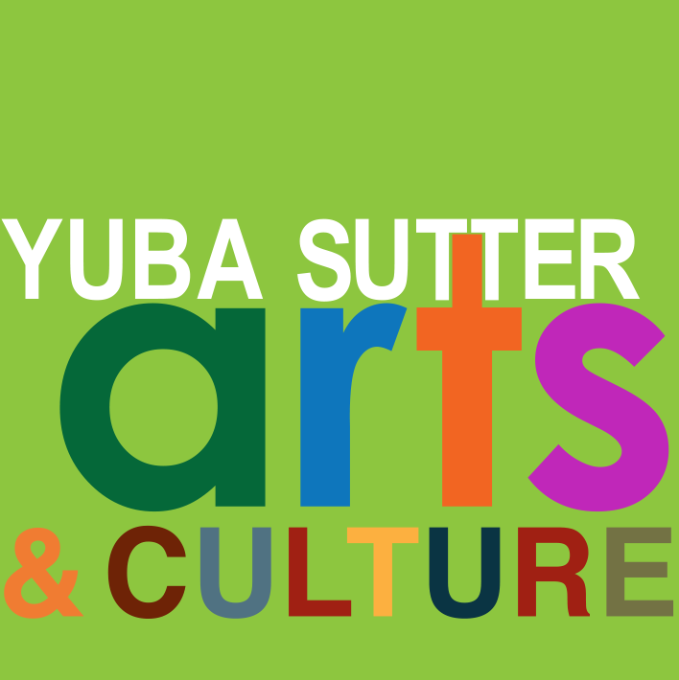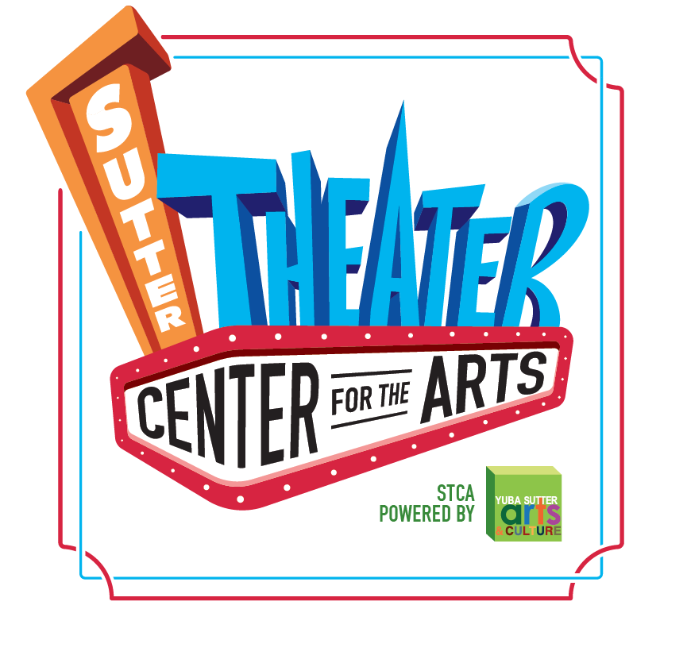
Media Contact:
Yuba Sutter Arts
David Read
530-742-2787
david@yubasutterarts.org

For Immediate Release

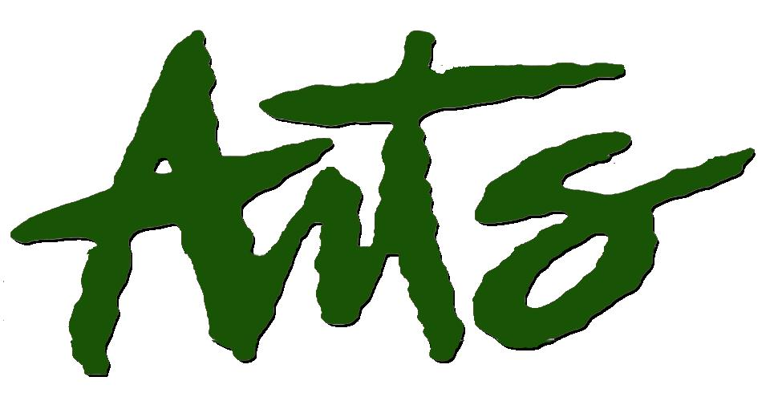
The California Arts Council is Comin’ to Town
January Board Meeting to be Held at the Sutter Theater Center for the Arts

Marysville, Calif., January 7, 2025 – The California Arts Council (CAC), of which Yuba Sutter Arts & Culture (YSAC) is the local affiliate, has chosen Yuba City and the Sutter Theater Center for the Arts as the site of its January Board of Directors meeting. The date for the meeting is Friday, January 24th and will be attended by arts leaders from around the state. This is a great honor for the Yuba-Sutter community and it’s a first in the 44-year history of YSAC. In addition to the eleven Council members and five staff from Sacramento, many other members of statewide arts agencies will be attending. The meeting is free and open to the public and is scheduled from 10 am to 4 pm with a short lunch break.

The California Arts Council has been a state agency since 1976. Its mission is to strengthen arts, culture, and creative expression as the tools to cultivate a better California for all. It supports local arts infrastructure and activities statewide through grants, programs, and services. In addition to grantmaking, the CAC advocates for the arts at the state and national levels. It works to secure funding, shape public policies, and raise awareness about the arts’ role in economic development, education, and social cohesion. Its partnerships with local arts agencies, schools, and nonprofits amplify its reach and impact. YSAC has been part of the CAC’s state-local partnership (SLP) program since 1981. Local arts agency SLPs represent 54 of the state’s 58 counties. SLP status requires the County’s authorization which YSAC has from both Yuba and Sutter counties and that a supervisor from each sits on the YSAC board of directors. The benefit of SLP status is an annual grant for some operational funding assuming the agency meets certain criteria. Additional grant opportunities are also available along with networking and collaborative opportunities with other arts organizations statewide.

The Executive Director of the CAC is Danielle Brazell, a national arts and culture leader who is passionate about the roles that arts, culture, and creativity play in advancing civic belonging, equity, economic prosperity, and social connectedness. Her career spans over thirty years, as an artist, teaching artist, presenter, arts administrator, and just prior to her appointment to the CAC by Governor Newsom, as the General Manager of the City of Los Angeles Department of Cultural Affairs. A passionate advocate, she continues to advance the support systems for creativity to thrive.

The California Arts Council’s history is a testament to the power of public investment in the arts. Over nearly five decades, it has supported countless artists and organizations, enriched communities, and celebrated the diverse cultural tapestry of the state. As it continues its work, the CAC ensures that the arts remain a vibrant and integral part of life in California. Why should the public attend? Come out and show your support for the arts. Consider speaking during the public comment section about how Yuba-Sutter residents value arts and culture in our rural community.

Feel free to contact Yuba Sutter Arts & Culture with any questions about this event as well as the long-term impact the California Arts Council has had on our community. Send an email to david@yubasutterarts.org. Go to yubasutterarts.org for information about other YSAC programs and events.

About YSA: Yuba Sutter Arts is a non-profit organization whose mission is to provide arts programming, education, advocacy, assistance and service to artists, organizations and residents of Yuba and Sutter Counties. The local affiliate for Yuba and Sutter of the California Arts Council, its programs include Arts in Education, Veterans Initiatives in the Arts, Center Stage Productions, Convergence Theatre Company, the Yuba Sutter Big Band, Very Special Arts Festival, Yuba Sutter Youth Choir, and many more. # End #

