
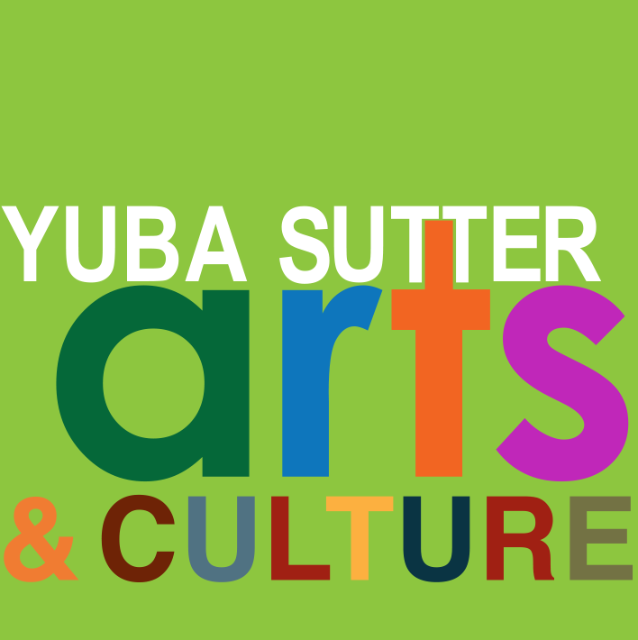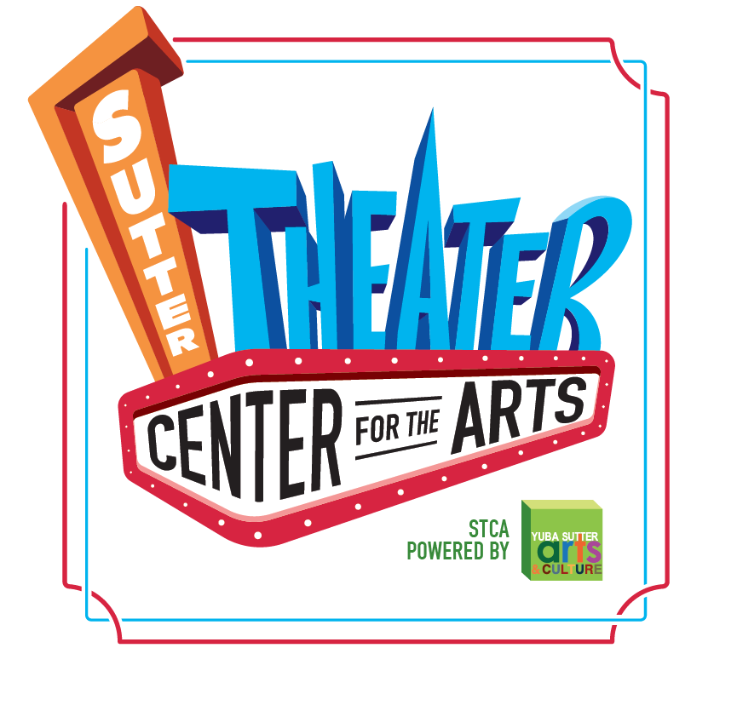
Media Contact:
Yuba Sutter Arts
David Read
530-742-2787
david@yubasutterarts.org

For Immediate Release

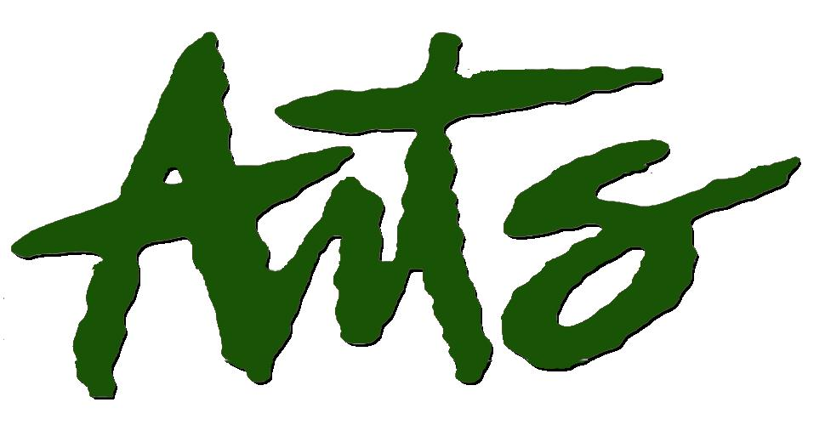
The Art Box Gallery Presents the Work of Not One,
Not Two, But Three Guest Artists

Marysville, CA. February 3, 2025 – The community recently saw an abundance of original works of art on display by high school students from across our region presented during the annual Scholastic Art & Writing Awards ceremony. Now Yuba Sutter Arts & Culture is pleased to present a gallery show featuring the work of arts educators from Yuba City High School who have led some of those students along their path in pursuit of artistic excellence. Come celebrate these incoming guest arts educators who are accomplished artists in their own right at the Art Box Art Gallery in the Sutter Theater Center for the Arts. The free opening reception will be held on Friday, February 7th from 5 – 7pm in the Gallery at 754 Plumas Street in Yuba City. The free event includes a wide variety of thought-provoking art, interesting people, great conversation, and free appetizers and drinks. The artists will talk about their work and what inspires them to create.

Here's the lineup…Carob Bradlyn has been making art since childhood and ceramics since high school. She is currently the art department chair at Yuba City High School and teaches…ceramics. Carob is currently experimenting with new glazes, clays and forms as well as mixed media. Denise Turner, another YCHS art teacher, uses watercolors, colored pencils, markers, and felt in her current art practice. She lived in the Rocky Mountains during the pandemic years and fell in love with the landscape, wildlife, and wildflowers. Denise has always made art but loves recreating some of the most beautiful memories she has of living in the wild nature of Wyoming through watercolors. Sally Hedley, also a YCHS art teacher, has always been fascinated by nature and its dangerous beauty. She sees the balance of life and death as fragile, and thinks we sometimes forget how precious and short life truly is. In this collection, she has strived to show a balance between light and dark, humor and fear, and thriving versus surviving. Sally works in watercolor and acrylic paints and ceramics.

The Art Box Gallery is located inside the Sutter Theater Center for the Arts. This month we also welcome in two new Anchor Artists. Emily Cordi is a Marysville Charter Academy for the Arts alumni and loves to create from recycled and foraged materials. She is inspired by the wildlife, nature, agriculture, and countryside of the Sutter Buttes near her family’s winery. Her current works include grapevine wreaths, recycled wine cork Christmas trees, wine bottle lanterns and hand painted reclaimed wood.

Laurie Trent-Butsch says she has always been a creator. For many years, she designed and made costumes for community theater and was also a professional photographer. Laurie began creating jewelry from vintage china in 2019 and started working with vintage silverware in 2020. She discovered a passion for working with unwanted, neglected silverware, bringing these pieces back to life as beautiful, wearable pieces of art that can convey stories of family and love.
These new Anchor Artists join two well-established Art Box artists. See original works of art created by former high school welding instructor turned metal sculpture artist, Dude Green, alongside Navy Veteran and retired arts educator, master ceramist Drew Sallee. Your purchase of a work of original art helps support the artists as well as Yuba Sutter Arts & Culture. For additional information about this exhibition and the reception, contact Yuba Sutter Arts & Culture at email@yubaustterarts.org.
About YSAC: Yuba Sutter Arts & Culture is a non-profit organization whose mission is to provide arts programming, education, advocacy, assistance, and service to artists, organizations, and residents of Yuba and Sutter Counties. The local affiliate for Yuba and Sutter of the California Arts Council, its programs include Arts in Education, Veterans Initiatives in the Arts, Arts in Corrections, Very Special Arts Festival, Convergence Theater Company, Center Stage Productions, the Yuba Sutter Big Band, Yuba Sutter Youth Choir, and many more.
# End #

