
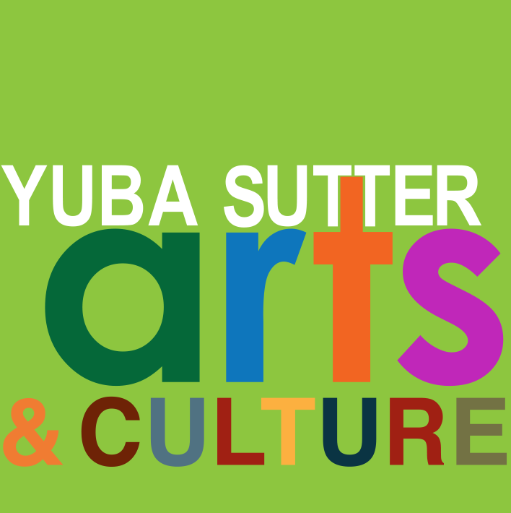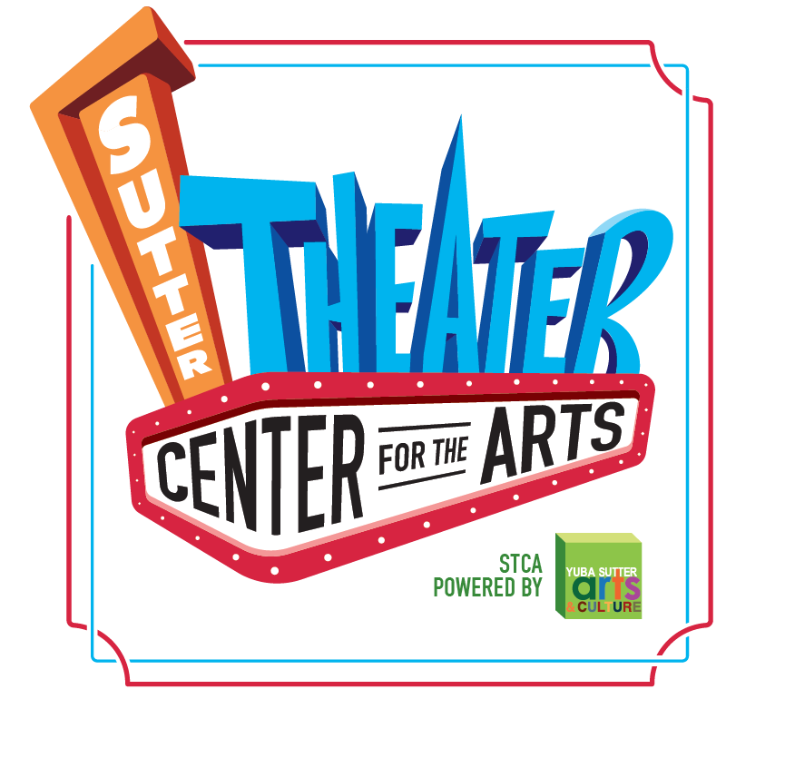
Media Contact:
Yuba Sutter Arts
David Read
530-749-8065
david@yubasutterarts.org

For Immediate Release

Love and Laughter Live Comedy Show
Keep the Valentine’s Day Vibe Going the Day-After

Marysville, Calif., February 5, 2025 – The Sutter Theater Center for the Arts has become the community’s destination for high quality entertainment in Yuba-Sutter. Professional comedy shows are no exception so get ready for a big night of laugh-out-loud fun when it brings a comedy showcase to town the day after Valentine’s Day, February 15th at 7pm. Doors open at 6. Snacks are available for purchase and the venue features a full bar. Admission to the show is $25 or $45 per couple using promo code: couplespecial25. All prices include the show and desserts. It’s all happening at the Sutter Theater Center for the Arts, 754 Plumas Street in Yuba City. 18+ only please.

The show will step it up with comedians who are straight outta the Sacramento/ San Francisco comedy circuit. Here’s the lineup. Tristan Johnson not only blazes comedy club stages across the nation, but he brings down the house with laughter no matter the venue including churches. He is the creator of one of Northern California’s most epic comedy rooms in Del Paso Heights called Nutty Mondays. As a country Texan raised in Oakland, Tristan’s comedy, like his upbringing, is best described as eclectic and adaptable. No matter what the setting, whether a comedy club, a church or a wet T-shirt contest at a rooftop bar, he adapts to win over any crowd. His descriptions of ordinary situations are hilarious and are guaranteed to make you laugh. Tristan has performed at the World Series of Comedy: Las Vegas and has opened for comedians like Dc Young Fly, Redd Grant and Lunell as well as for comedian Tacara Williams at the Super Funny Comedy Club in 2021.

Rounding out the talent line up is local comedienne, Sinn Rella, who is also an author, corporate consultant and motivational speaker. She grew up in Oakland and has been performing comedy for many years. Sinn has just written a book that is a funny read titled “The Bitter Bitch Chronicles” available on Amazon. She has performed comedy on the road appearing in many comedy venues and was once named the funniest female in New Jersey. She was a finalist in the Ladies of Laughter 2018 and the She Devil Competition in New York in 2015. Sinn was also a member of the “Real Funny Housewives of Rio Linda.” Her fiery comedy material includes many of her real-life experiences like growing older and working in an office. She also covers her experiences with her kids and grandkids. She noticed that women of the world needed a sign to bond and to let each other know that we are all together as she brings the laughter to the room. So, she came up with her own original motto, “Left ti**y, right ti**y, Sister Power!” It sounds even better when she says it.

Come out and “LYAO” at comedy night at the Sutter Theater Center for the Art. Tickets available at yubasutterats.org or contact the office at 530-742-ARTS.

About YSAC: Yuba Sutter Arts & Culture is a non-profit organization whose mission is to provide arts programming, education, advocacy, assistance, and service to artists, organizations, and residents of Yuba and Sutter Counties. The local affiliate for Yuba and Sutter of the California Arts Council, its programs include Arts in Education, Veterans Initiatives in the Arts, Arts in Corrections, Very Special Arts Festival, Convergence Theater Company, Center Stage Productions, the Yuba Sutter Big Band, Yuba Sutter Youth Choir, and many more. # End #

