
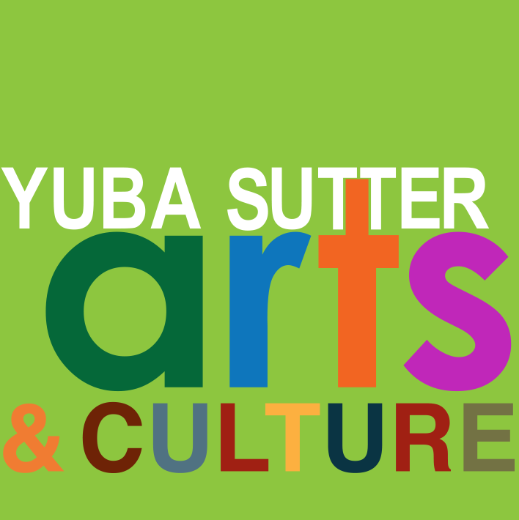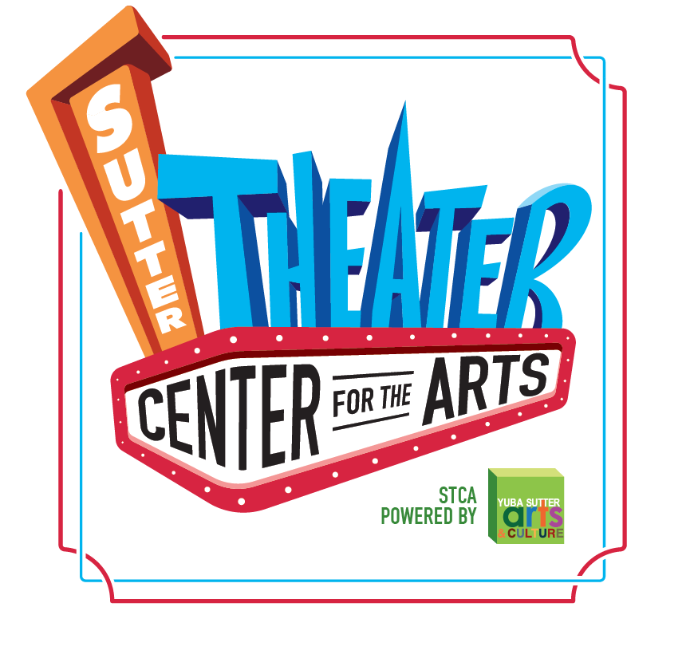
Media Contact:
Yuba Sutter Arts
David Read
530-742-2787
david@yubasutterarts.org

For Immediate Release

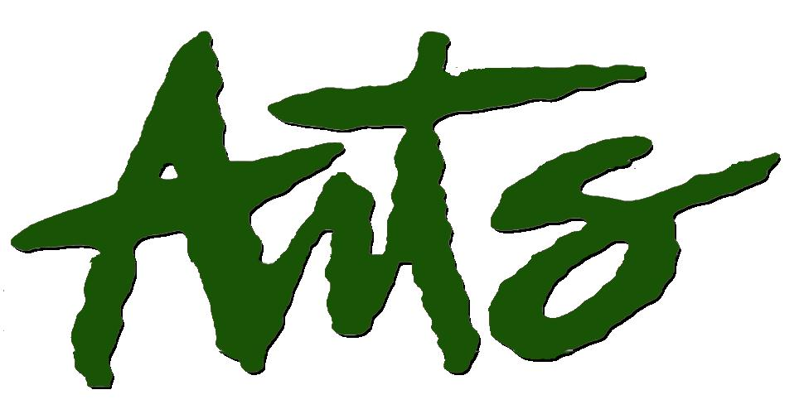
New Addition to the Murals of Live Oak
Rebecca Wallace Returns and Adds to the Outdoor Art Gallery

Marysville, Calif., January 22, 2025 – Live Oak has a new addition to its collection of spectacular murals. This one is on the side of the Live Oak Fire Station, 2745 Fir Street. The artist is Rebecca Wallace who has been part of the Murals of Live Oak almost since its inception. Her earlier murals include the one titled “Connected” on the side of the Barber Branch Library, and “The Happy Peach Farmer,” on the old Sunny’s Market which was part of Live Oak Mural Marathon. She also recently repaired the “Then and Now” mural on the side of the AT&T building near City Hall which was designed by Stephane Cellier.

The newest mural has a fire station theme. No surprise there. Working closely with Fire Chief Richard Epperson, the concept evolved from some early reference images to the now completed 60’ mural. After several iterations, the final design was approved. Due to the rough nature of the stucco exterior wall, the mural took a few days longer than originally planned but the warm, dry days worked to the artist’s advantage. Rebecca completed the mural on Wednesday, January 15th.

Rebecca Wallace is a painter and muralist residing in Northern California where she teaches art classes at Mendocino College. She is also the owner and operator of her own mural business Wallace Murals and Designs. Rebecca taught art classes at Yuba College for five years, during which time she worked closely with Yuba Sutter Arts & Culture teaching art to incarcerated juveniles and adults. In 2022 she was commissioned by the city of Redding to complete multiple murals for the Stress Ribbon Bridge along the Sacramento River. That same year she was also selected to paint the large-scale mural for Yuba College’s Theater Arts Building. She has also been selected to create two new murals for a new Public Safety Building in Reno, Nevada slotted for later this year. Rebecca was a recipient of the Murphy Cadogen Fellowship in Fine Arts and a finalist for the Tournesol Award in the Headlands Center for the Arts in Sausalito. Rebecca trained at San Francisco State and California College of the Arts, earning a Master of Fine Arts in painting and drawing. Her work has been shown in various shows throughout the United States. You can view her work on her website at wallacemuralsanddesigns.com.

Go to yubasutterarts.org for information about other Yuba Sutter Arts & Culture projects, programs and events.

About YSA: Yuba Sutter Arts is a non-profit organization whose mission is to provide arts programming, education, advocacy, assistance and service to artists, organizations and residents of Yuba and Sutter Counties. The local affiliate for Yuba and Sutter of the California Arts Council, its programs include Arts in Education, Veterans Initiatives in the Arts, Center Stage Productions, Convergence Theatre Company, the Yuba Sutter Big Band, Very Special Arts Festival, Yuba Sutter Youth Choir, and many more.
# End #

