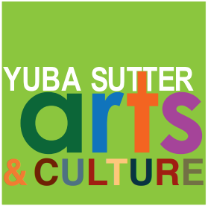 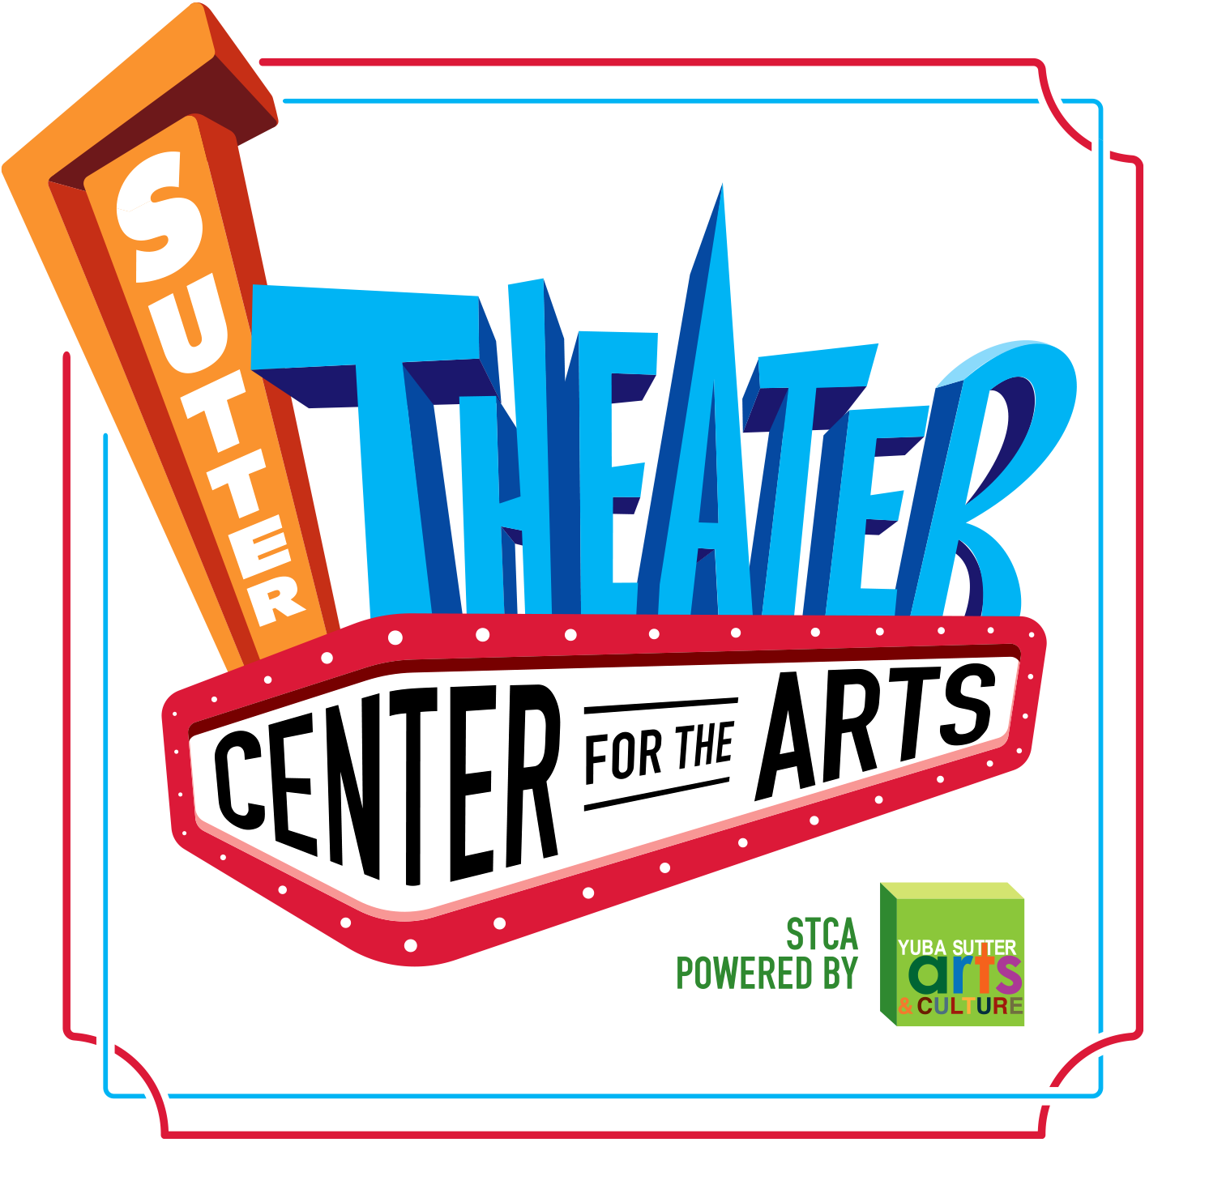

**Media Contact:**

Yuba Sutter Arts

David Read

530-749-8065

david@yubasutterarts.org

**For Immediate Release**

**Yuba and Sutter County “Poetry Out Loud” Champions Announced**

**Now on to the State Finals in Sacramento to Bring Home the Gold!**

Marysville, Calif., February 3, 2025 – Yuba Sutter Arts & Culture (YSAC) has been hosting an annual Poetry Out Loud recitation competition for local high school students almost since the inception of the program. It was begun in 2005 by the National Endowment for the Arts under the direction of former California State Poet Laureate, Dana Gioia. On Saturday, February 1st, Yuba Sutter Arts & Culture held its 2025 Poetry Out Loud competitions for both counties at its Sutter Theater Center for the Arts and is pleased to announce this year’s County Champions.

This year’s Sutter County winners are, First Place – Angeleek Viola, River Valley High School, Second Place - Efrain Ibarra Maldonado, River Valley High School, and Third Place - Aubree Bell, Sutter Union High School. The Yuba County winners are, First Place – Devon Giardini, Marysville Charter Academy for the Arts, Second Place -Lisette Perez, Marysville Charter Academy for the Arts, and Third Place - Sally Leonard, Marysville Charter Academy for the Arts. Judging was based on physical presence, voice and articulation, dramatic appropriateness, level of complexity, evidence of understanding, accuracy, and overall performance. Angeleek Viola recited *After Love* by Sara Teasdale and Devon Giardini recited *Meditation at Lagunitas* by Robert Haas. All finalists receive cash prizes, and the two county champions will receive a travel stipend to compete at the state finals in Sacramento.

Poetry Out Loud is a national program that encourages students to learn about great poetry through memorization and recitation. Students select poems from the Poetry Out Loud online anthology of nearly 1,000 poems. It helps students master public speaking skills, build self-confidence, and learn about literary history and contemporary life. Poetry Out Loud has grown over the years to include more than 3 million students and 50,000 teachers from 10,000 schools in every state, Washington, DC, the US Virgin Islands and Puerto Rico.

The two county winners will go on to compete in the California Poetry Out Loud state finals March 16-17.  The state finals competition will be in person at a yet to be announced location. At the state level, one winner will be selected to represent California in the national competition in Washington, D.C., May 5 - 7. For additional information about this and other Yuba Sutter Arts & Culture programs and events, call 530-742-ARTS or write to david[@yubaustterarts.org](mailto:email@yubaustterarts.org).

**About YSA:** Yuba Sutter Arts is a non-profit organization whose mission is to provide arts programming, education, advocacy, assistance and service to artists, organizations and residents of Yuba and Sutter Counties. The local affiliate for Yuba and Sutter of the California Arts Council, its programs include Arts in Education, Veterans Initiatives in the Arts, Arts in Corrections, Very Special Arts Festival, Center Stage Youth Performing Arts, Convergence Theater Co., the Yuba Sutter Big Band, the Yuba-Sutter Youth Choir and many more.

**# End #**