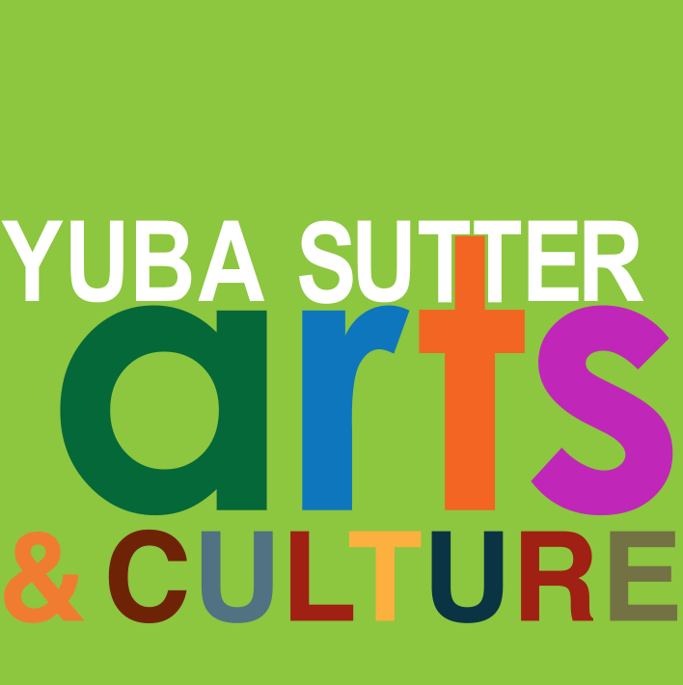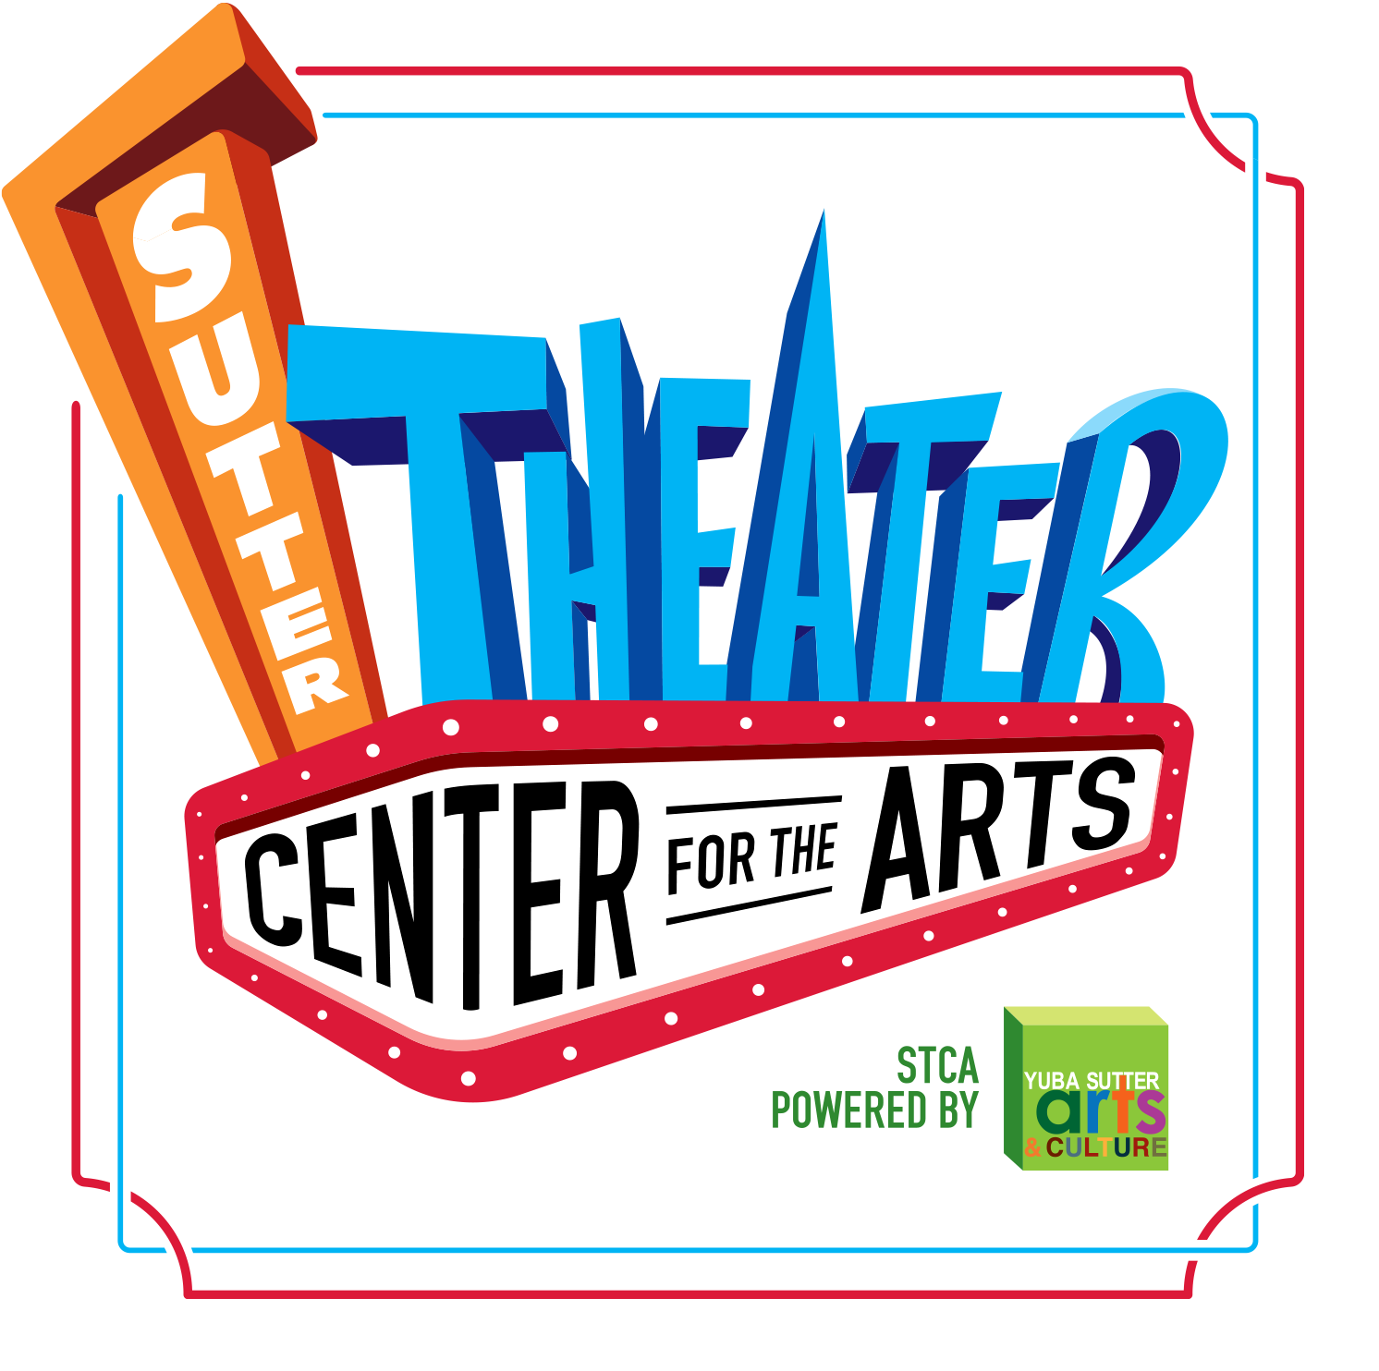
BOARD MEETING AGENDA
Always Open to the Public
Yuba Sutter Arts Board of Directors Meeting
Wednesday, July 26, 2023, 6:00 pm
754 Plumas Street, Yuba City, CA 95991

NOTE: This will be a virtual meeting via Zoom. A call-in number and access code is also listed. If for any reason you are unable to access the meeting on your computer, you will be able to listen and comment by phone. https://us02web.zoom.us/j/85974158970
+1 301 715 8592 US call in number if needed.

Land Acknowledgement Statement

Yuba Sutter Arts & Culture would like to carry forward a practice of recognizing the original caretakers of these lands within and throughout the Northern California region. Yuba-Sutter is within the ancestral lands of the Enterprise Rancheria of Maidu Indians. In 2016 the United States Federal Government restored 40 acres of trust land to the tribe on Forty-mile Road in Yuba County to replace some of the land that was taken during the construction of the Oroville Dam. We offer gratitude to these indigenous ancestors, and present-day relations of the Maidu. We acknowledge their stewardship of these lands over many centuries and uplift their legacies as they continue to build and sustain their culture and practices today. We are honored and grateful to be here today on their traditional territory.

- Executive Committee Meeting 5:30pm

- Call to Order/Roll Call 6:00pm

- Consent Agenda
  - Additions and/or Approval of Agenda
  - June Minutes
  - Fiscal Year Financials 7-1-22 through 6-30-23/P&L and Balance Sheet

- Art Moments – Share something positive about YSAC in the community or feel free to discuss any other art experiences you have had this past month.

- Public Communication - Any person may speak on any topic provided it is within the purview of Yuba Sutter Arts and is not already on today’s agenda. The time allotted for public communication will be no more than 3 minutes per person or group.

- Managing Director’s Report

- Executive Director’s Report

- Committee Reports
  - Finance Committee – Alondra
  - Harvest the Arts
  - Facilities/Refurbishment Committee – David
    - Replace or repair neon lights at front of STCA?

- General Topics/Discussion
  - Congratulations to our Officers for the 2023/2024 Year
    - President – Susan Miller
    - Vice President – Tom Galvin
    - Secretary – Narinder Dhaliwal
    - Treasurer – Alondra Bains
  - Board Dues
  - CA Conservation Corps Grant update
  - Jump StArts Grant update
  - Discuss comments by the Editor of the Appeal Democrat via email to YSAC Executive Director

- Action Items
  - Review and approve FY 2023-2024 budget.

- Adjournment – Next Board Meeting - Wednesday, August 28, 2023

