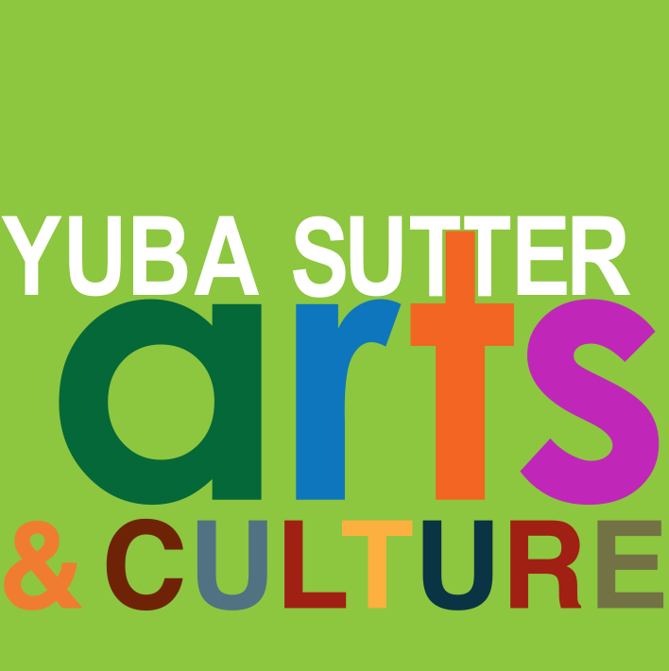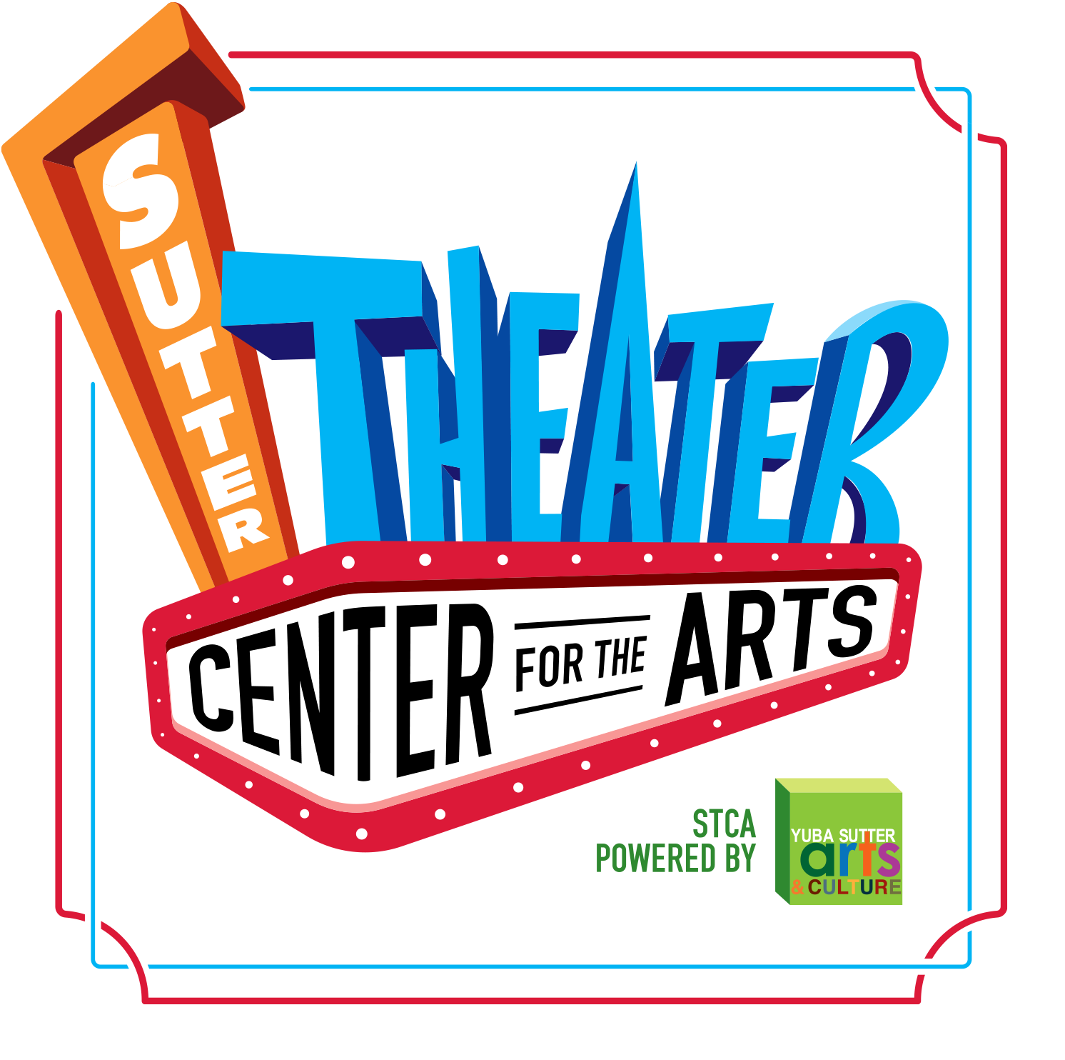
BOARD MEETING MINUTES
Always Open to the Public
Yuba Sutter Arts Board of Directors Meeting
Wednesday, June 28, 2023, 6:00 pm
754 Plumas Street, Yuba City, CA 95991

The meeting will be held in person at the Sutter Theater Center for the Arts, 754 Plumas Street in Yuba City.

Land Acknowledgement Statement

Yuba Sutter Arts & Culture would like to carry forward a practice of recognizing the original caretakers of these lands within and throughout the Northern California region. Yuba-Sutter is within the ancestral lands of the Enterprise Rancheria Estom Yumeka Maidu Tribe. In 2016 the United States Federal Government restored 40 acres of trust land to the tribe on Forty-mile Road in Yuba County to replace some of the land that was taken during the construction of the Oroville Dam. We offer gratitude to these indigenous ancestors, and present-day relations of the Maidu. We acknowledge their stewardship of these lands over many centuries and uplift their legacies as they continue to build and sustain their culture and practices today. We are honored and grateful to be here today on their traditional territory.

- Doors Open 5:30pm

- Call to Order/Roll Call 6:00pm
Board Present: Susan Miller, Tom Galvin, Linda Plummer, Sharon Foote, Glen Everett, Don Blaser, Shon Harris
Staff Present: David Read, Abbie Cesena, Shawntay Arroyo

- Consent Agenda
  - Additions and/or Approval of Agenda
Tom made a motion to approve, Sharon seconded. The motion passed unanimously.

- Public Communication - Any person may speak on any topic provided it is within the purview of Yuba Sutter Arts and is not already on today’s agenda. The time allotted for public communication will be no more than 3 minutes per person or group.
No one was present for public comment.

- Action Items
  - Election of Officers for the 2023/2024 Year by vote of the current Yuba Sutter Arts’ membership
    - President – Susan Miller
    - Vice President – Tom Galvin
    - Secretary – Narinder Dhaliwal
    - Treasurer – Alondra Bains
Shon made a motion to approve and Sharon seconded. The Board and the Membership voted
unanimously to approve the Election of Officers as listed.

- Special Presentations
  - Susan Miller, YSAC Board President – Retiring Board Members Recognition
  - Abbie Cesena, Managing Director and Shawntay Arroyo, Arts in Education Coordinator –
    - Volunteer of the Year
    - The “Above and Beyond” Award
  - David Read will make a presentation on the “State of the Arts and Culture in Yuba-Sutter.”

- Adjournment – Next Board Meeting - Wednesday, July 26, 2023
Don made a motion to adjourn at 7:14pm, Sharon seconded. The motion carried unanimously.

